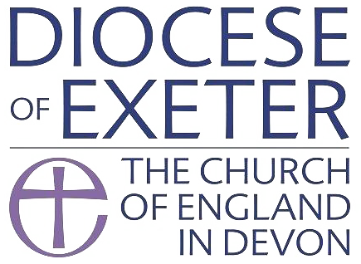

St James the Less Parish Safeguarding Policy Statement

Statement of Safeguarding Principles

The Plymouth Partnership in Mission fully recognises and accepts the House of Bishops’ Safeguarding Policy Statement “Promoting a Safer Church 2017”, and commits to complying with the current Church of England and Diocesan safeguarding policies and practice guidance. In so doing we will comply with the secular multi-agency safeguarding procedures relating to children and young people and adults experiencing or at risk of harm, abuse or neglect.

We are committed to:

- Promoting a Safer environment and culture within our Parish and in our Parish activities by adhering to safe working practices and acknowledge the principle that safeguarding is everyone’s business.

In addition we will ensure that any individual organisation renting/using our premises for activities involving children, young people or vulnerable adults is aware of this, our Safeguarding Policy, and aware of their own individual responsibilities to have appropriate safeguarding policies and processes in place, including safer recruitment.

- Safely recruiting and supporting all those with any responsibilities related to children, young people and vulnerable adults within the Church in accordance with the House of Bishops’ Safer Recruitment: Practice Guidance 2016.

We will ensure those appointed are aware of the Diocesan and Parish Safeguarding Policies and are aware of their roles and responsibilities. We will support them by ensuring they receive Diocesan safeguarding training commensurate with their role and that they are fully aware of and have access to the practice guidance.

- Responding promptly to every safeguarding concern or allegation in accordance with the statutory child and adult safeguarding procedures and the House of Bishops’ safeguarding practice guidance.

We will ensure that any complaint made regarding a vulnerable person, who may have been harmed or is in significant danger, will be reported immediately and we will fully cooperate with statutory agencies during any investigation into allegations concerning a member of the church community or any other person.

- Caring pastorally for victims/survivors of abuse and other affected persons.

We will seek to offer informed pastoral care and support to anyone who has suffered abuse, developing with them an appropriate ministry that recognises the importance of understanding the needs of those who have been abused, including their feelings of alienation and/or isolation and provide them with details of local and national support agencies.

- Caring pastorally for those who are the subject of concerns or allegations of abuse and other affected persons.

We will work with others to ensure the appropriate support for them and those affected. Where that person is considered to pose a risk to others, we will work with the Diocesan Safeguarding Advisor to mitigate any identified risk.

- Responding to those that may pose a present risk to others.

We will endeavor to offer pastoral care and support whilst ensuring any risk has been assessed and is being managed in accordance with House of Bishops’ policy and guidance and in collaboration with the statutory agencies and the Diocesan Safeguarding Advisor.

Safeguarding representative
We will ensure that there is an identified person/s to be the Parish Safeguarding Representative/s who will be suitably recruited and trained, and is aware of their role and responsibilities, and who will be the point of contact for any concerns.

We have appointed Gareth Skyrme as our Parish Safeguarding Representative/s. He is contactable at stjamessafeguarding@outlook.com

Guidance
Copies of Diocesan and parish guidelines and procedures are held by/can be accessed at www.stjamesplymouth.com.

Review
This policy will be formally reviewed annually and a copy shared with the Archdeacon at the time of the Visitation.

Date of Adoption
The Trustees of this Church agreed and adopted the above Policy at its meeting on 04/03/2021.
The Trustees shall review this policy annually. The next review will take place at the first meeting in March 2022.

Signed

Lead Clergy Rev Phillip Brokenshire

PPIM Chair of Trustees Archdeacon Nick Shutt

PPIM Trustee Chris Forster

Date 05/03/2021

Template Revision History

Version No. | Revision Date | Summary of Changes | Author
1.0 | 18/08/2017 | Initial version. | Charlie Pitman
1.1 | 06/08/2020 | Added revision history and renamed. | Phill Parker

